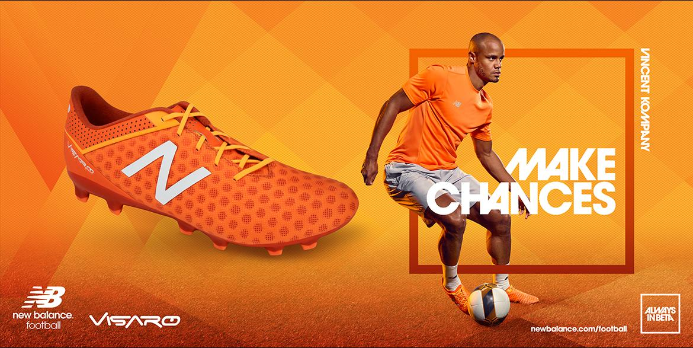

Invention Worksheet—
Rhetorical Analysis
Answer each question, referencing written and visual evidence from the advertisement to support your conclusions about how the ad uses rhetoric to achieve a purpose and send a message. Your work on this invention worksheet will provide you with claims and evidence that you can use to write your Rhetorical Analysis.
This worksheet is due at 10:30 p.m. on Sunday, September 12.
I. Rhetorical Situation Information About Your Advertisement
Ads typically try to sell a product (like Nacho Fries!) or try to deliver a specific message. Determine which is most relevant for your ad, and answer the corresponding questions below.
A. Products
a. Product Being Advertised:
b. Company that produces the product and is thus the sponsor (author) of the ad? c. What is the purpose of the product?
d. Approximately how much does the product cost?
e. Who would be most likely to use the product?
B. Messages
a. What message is the ad trying to send?
b. Who is sponsoring (and thus author of) this ad?
c. What is the purpose of the message?
d. Are there costs associated with answering the message?
e. Who would be most interested in this message?
Publication Source
1. Who are the primary readers/viewers of this ad? Consider some of the relevant details of the readers’ social identity—such as class, race, gender, sexuality, age, religion, special interest, etc.
2. Where would you expect to see this ad? Is the general readership/viewership the same as the target consumers for your ad? Explain why (or why not) you believe the target consumers are part of the source’s general readership. Consider ways in which the target audience for the ad might be narrower than the target audience for the source as a whole.
II. Rhetorically Analyzing Your Advertisement’s Claims and Evidence
1. ETHOS (CREDIBILITY): What kind of ethos does your advertisement try to assign to the product or to the company selling the product? Does the ad try to establish a particular image for the product or company—that is, an ethos or character for the product or company? Describe the image the ad projects about the product or company.
WRITTEN EVIDENCE:
VISUAL EVIDENCE:
2. PATHOS (EMOTIONS): What appeals to emotion does your ad employ? (Remember to list specific emotions.) Once you have stated the ad’s (implied or explicit) primary emotional claim, use the space below to list the most important written and visual evidence the ad uses to support that claim.
EMOTIONAL CLAIM(S):
WRITTEN EVIDENCE:
VISUAL EVIDENCE:
3. PATHOS (VALUES) What appeals to specific values or identities does your ad employ? Once you have stated the ad’s (implied or explicit) primary value or identity claim, use the space below to list the most important written and visual evidence the ad uses to support that claim.
VALUE/IDENTITY CLAIM:
WRITTEN EVIDENCE:
VISUAL EVIDENCE:
4. LOGOS: What appeals to reason does your ad employ? (In other words, what factual claims does the ad make about the quality and the characteristics of the product?) Once you have stated the ad’s primary appeal to reason, use the space below to list the most important written and visual evidence the ad uses to support that claim.
APPEAL TO REASON:
WRITTEN EVIDENCE:
VISUAL EVIDENCE:
2
III. Your Advertisement’s Use of Rhetoric to Send a Message
1. What rhetorical appeals and which elements of visual rhetoric are used most in the ad to achieve its purpose?
2. Based on its target audience, why does the ad use specific rhetorical appeals and visual rhetoric?
3. What message does the ad seem to be sending? The message is different from the purpose— for example, an ad may try to sell you a car while also sending the message that the company that makes the car is environmentally responsible.
4. Why is this message appropriate for the target audience?
3

